KNOWLEDGE & TECHNOLOGY

Bangladesh Army University of Engineering & Technology



Department of Computer Science and Engineering

A project on

**Meta-Estate**

Supervised by

Md. Omar Faruq

Lecturer, Department of CSE, BAUET

Md. Nazmus Salehin

Lecturer, Department of CSE, BAUET

Mst. Irin Sultana

Lecturer, Department of CSE, BAUET

Submitted by

Sakib Raihan (18204009)

Md. Shah Abrar Zahin (18204021)

MD. Touhid Iqbal Sagar (18204023)

Md. Abdullah Al Fahad (18204025)

Mst. Rukhtaj Ara Choitee (18204031)

Department of Computer Science and Engineering

Bangladesh Army University of Engineering & Technology

April, 2022

KNOWLEDGE & TECHNOLOGY

Bangladesh Army University of Engineering & Technology

Department of Computer Science and Engineering



**CERTIFICATE**

This is to certify that the project entitled “Meta-Estate” by “Sakib Raihan”, ID No.: 18204009, “Md. Shah Abrar Zahin”, ID No.: 18204021, “MD. Touhid Iqbal Sagar”, ID No.: 18204023, “Md. Abdullah Al Fahad”, ID No.: 18204025, “Mst. Rukhtaj Ara Choitee”, ID No.: 18204031, has been accepted as satisfactory in partial fulfilment of the requirement for the degree of Bachelor of Science in Computer Science and Engineering on April, 2022.

Signature of Supervisor

(Md. Nazmus Salehin)

(Lecturer)

Department of CSE

BAUET

Signature of Supervisor

(Mst. Irin Sultana)

(Lecturer)

Department of CSE

BAUET

Signature of Supervisor

(Md. Omar Faruq)

(Lecturer)

Department of CSE

BAUET

KNOWLEDGE & TECHNOLOGY

**Bangladesh Army University of Engineering & Technology**

Department of Computer Science and Engineering



**DECLARATION**

I thereby declare that our project entitled “Meta-Estate” is the result of our work. We also ensure that it does not previously submitted or published elsewhere for the award of any degree or diploma.

The work has been accepted for the degree of Bachelor of Science in Computer Science and Engineering at Bangladesh Army University of Engineering & Technology (BAUET).

**Authors**

**Sakib Raihan (18204009)**

**Md. Shah Abrar Zahin (18204021)**

**MD. Touhid Iqbal Sagar (18204023)**

**Md. Abdullah Al Fahad (18204025)**

**Mst. Rukhtaj Ara Choitee (18204031)**

**ACKNOWLEDGMENT**

We are highly indebted to our course teacher for their guidance and constant supervision as well as for providing necessary information regarding the project & also for their support in completing the project.

Sakib Raihan (18204009)

Md. Shah Abrar Zahin (18204021)

MD. Touhid Iqbal Sagar (18204023)

Md. Abdullah Al Fahad (18204025)

Mst. Rukhtaj Ara Choitee (18204031)

**ABSTRACT**

Web-based project management software is a type of software that allows users to work on collaborative projects online. This software allows streamlining distributed workflows, replacing email operations and improving remote collaborative work. We are usually familiar with visiting properties face to face. So, we have decided to build a web app to visit properties virtually. Which is more time efficient and cost effective. We have used very popular programming language HTML, CSS, C#, PHP, JS and unreal engine to build this web-based application.

|  |  |  |
| --- | --- | --- |
| **List of contents** | | |
| **Chapter** | **Title** | **Page No.** |
|  | Certificate | ii |
|  | Declaration | iii |
|  | Acknowledgment | iv |
|  | Abstract | v |
|  |  |  |
| 1 | **INTRODUCTION** | 1-2 |
|  | 1.1 Introduction | 1 |
|  | 1.2 Objectives |
|  | * 1. Advantages   2. Disadvantages | 2 |
|  |  |  |
| 2 | **BACKGROUND STUDY** | 3-4 |
|  | 2.1 Introduction | 3 |
|  | 2.2 Existing system  2.3 Conclusion | 4 |
|  |  |  |
| 3 | **PROPOSED MODEL** | 5-8 |
|  | 3.1 Introduction | 5 |
|  | 3.2 Flow-chart | 6 |
|  | 3.3 Use-case Diagram | 7 |
|  | 3.4 Entity Relation (ER) Diagram | 8 |
|  |  |  |
| 4 | **IMPLEMENTATION** | 9-38 |
|  | 4.1 Introduction  4.2 Visual Representation of Our System | 9 |
|  |  |  |
| 5 | **CONCLUSION & COMPARISON** | 39-40 |
|  | 5.1 Introduction  5.2 Conclusion | 39 |
|  | 5.3 Comparison | 40 |
|  | **REFERENCES** | 41 |

|  |  |  |
| --- | --- | --- |
|  | **List of figures** |  |
| **Figure No.** | **Title** | **Page No.** |
| 3.1.1 | Incremental model | 5 |
| 3.2.1 | Flow chart of meta-estate | 6 |
| 3.3.1 | Use-case Diagram of Meta-Estate | 7 |
| 3.4.1 | Entity Relation (ER) Diagram of Meta-Estate | 8 |
| 4.1.1 | Home page | 10 |
| 4.1.2 | About us | 11 |
| 4.1.3 | Sales page | 12 |
| 4.1.4 | Properties page 1 | 13 |
| 4.1.5 | Properties page 2 | 14 |
| 4.1.6 | Sign-up page | 15 |
| 4.1.7 | Log in page | 16 |
| 4.1.8 | Welcome page | 17 |
| 4.1.9 | Properties page | 18 |
| 4.1.10 | Messenger option page | 19 |
| 4.1.11 | Our Facebook page | 20 |
| 4.1.12 | Facebook page’s link button | 21 |
| 4.1.13 | XAMP home page for database | 22 |
| 4.1.14 | Database page | 23 |
| 4.1.15 | Data table of the database | 24 |
| 4.1.16 | Boral hall’s room’s 3D view 1 | 25 |
| 4.1.17 | Boral hall’s room’s 3D view 2 | 26 |
| 4.1.18 | Living room of an apartment | 27 |
| 4.1.19 | Bed room of an apartment | 28 |
| 4.1.20 | Drawing room of an apartment | 29 |
| 4.1.21 | kitchen of an apartment | 30 |
| 4.1.22 | The washroom of an apartment | 31 |
| 4.1.23 | Outside of the apartment | 32 |
| 4.1.24 | Map of the apartment area | 33 |
| 4.1.25 | The top view of the apartment | 34 |
| 4.1.26 | The outside view of an apartment | 35 |
| 4.1.27 | The Park | 36 |
| 4.1.28 | The gorgeous stairs of the park | 37 |
| 4.1.29 | The top view of the park | 38 |

viii

**Chapter 1**

**INTRODUCTION**

**1.1 Introduction**

The term web application refers to a software system that provides a user interface through a web browser. Examples of web applications include blogs, online shopping, search engines, online property visiting etc. Web applications can be simple consisting of only static web pages or they can be dynamic and interactive. Static web pages are stored in the file system of web server usually displays the same information to all visitors. Whereas dynamic pages are constructed by a program that produce the HTML. This type of web application provides individual information to the user and let them personalize the content according to their preferences.

A web application reduces costs for both the end-user and the business. Web applications are always up to date because updates are applied centrally. All users can access the same version so it eliminates any compatibility issues. You can access web applications anywhere with a web browser.

**1.2 Objectives**

Web apps have the typical front-end and back-end web development technologies. In theory, web apps are closely related to websites, thus web app development and web development share many characteristics. Web applications have a directory structure, which is fully accessible from a mapping to the application's document root (for example, /hello). The document root contains JSP files, HTML files, and static files such as image files. A WAR file (web archive file) contains a complete web application in compressed form.

**1.3 Advantages**

1. Requires no disk space
2. Reduce business costs

**1.4 Disadvantages**

1. Slower and runs over internet
2. Requires compatible web browsers
3. Lack of flexibility.

**Chapter 2**

**BACKGROUND STUDY**

**2.1 Introduction**

The first step is obviously the most basic one. If you are reading this article you might already have a basic idea in mind. But is that enough? Your idea about the web app needs to be highly specific. It should aim to solve a specific problem or perform a specific set of functions. Using HTML, CSS, C#, PHP, JS programming language, we are going to build an economical web application for property dealing. Specifically, this app here is real estate 3D web application [1].

Our goal is to have something which is going to be a user-friendly 3D web app that will help user to visit properties virtually. He doesn’t have to visit the place physically. If he choice the property then he can contact with us and can visit the property physically before purchasing. There are large numbers of commercial real estate online information service providers offering a suite of commercial properties and services tailored to the national and local needs of the commercial investments industry.

Web 3D is a term used to describe interactive 3D content included in an HTML page, viewable by a common Web browser via a special 3D viewer. It uses the concept of Web 3D also indicate a possible evolution of the Web where the idea was abandoned page.

**2.2 Existing system:**

We have researched a lot to find an existing system and find a few of them but those are not identical to ours. We have inspected some house selling websites like “retailor” [2]. And also visited the New Zealand virtual pavilion on Dubai expo 2020 to see how 3D objects looks like in a website [3]. We have also find an existing system called the next gallery (<https://www.thenext.gallery/>) which portray a gallery of some influential people in 3D space. And also represents a photo gallery in a 3D web view [4]. But in our web app, we have a 3D house design where user can experience the whole house in 3D using any browser.

**2.3 Conclusion:**

Our proposed project is “Meta-Estate” - A 3D based home selling web application. It’s a new generation of web where we want to introduce it with the world. Though there are some architectural, environmental designing website exists from 2007 but we have implemented this technology for the first time in web platform. Where we are able to see 3D architectural view of a real environment in any type of web browser.

**Chapter 3**

**PROPOSED MODEL**

**3.1 Introduction**

Our proposed model is incremental model to create a 3D based real estate web application.

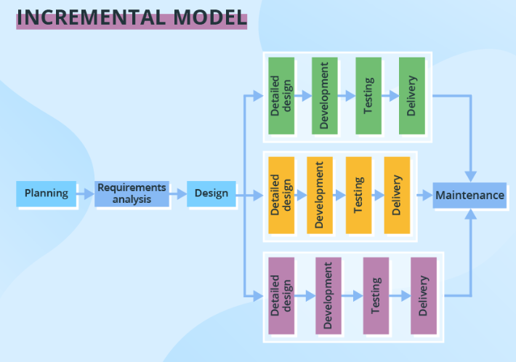The development process based on the Incremental model is split into several iterations (“Lego-style” modular software design is required!).

Figure 3.1.1: Incremental Model

New software modules are added in each iteration with no or little change in earlier added modules. The development process can go either sequentially or in parallel. Parallel development adds to the speed of delivery, while many repeated cycles of sequential development can make the project long and costly.

**3.2 Flow-chart**

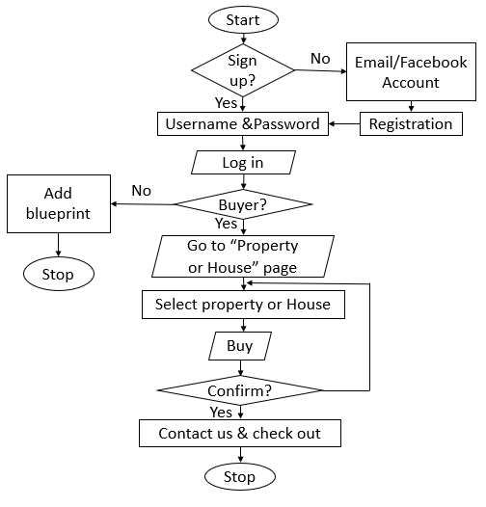

Figure 3.2.1: Flowchart of Meta-Estate

This is the flowchart of our web app. At first, the user has to sign up through his Email or Facebook account. He was also required to put his password for login. After completing the sign-up process, the user can log in to his account. If he is a buyer then he can go to the “Property or House” page. Then he has to select his desired house. If he wants to buy it then he has to confirm it through the check-out option.

**3.3 Use-case Diagram:**

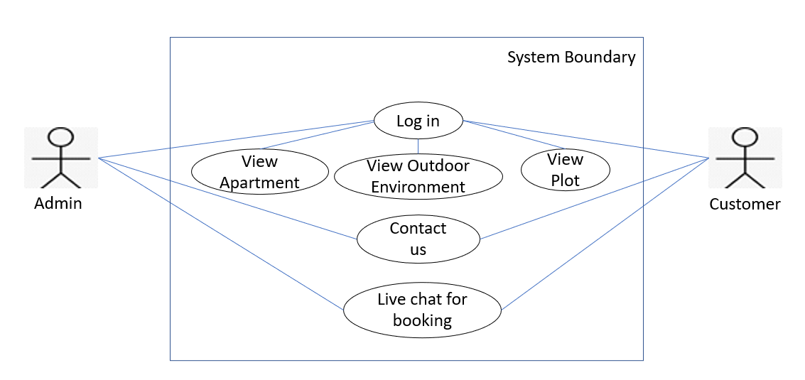

Figure 3.3.1: Use-case Diagram of Meta-Estate

Here, we can see we have two actors, admin and customer. Both admin and customer can log in to our website. After log in they can see the dashboard including view apartment, view outdoor environment and view plot. Customer can contact with us and for any query customer can do live chat with us.

**3.4 Entity Relation (ER) Diagram:**

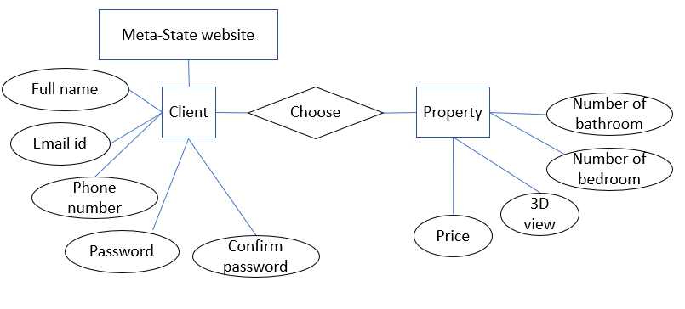

Figure 3.4.1: Entity Relation (ER) Diagram of Meta-Estate

From our meta-estate website, client or user can sign up or log in with his or her full name, email id, phone number, password and confirm password. Client can choose property option only after sign up to our website. Inside the property, he or she can see the number of bedrooms, number of bathrooms, the 3D view of the room and price

**Chapter 4**

**IMPLEMENTATION**

**4.1 Introduction**

The implementation phase involves putting the project plan into action. It’s here that the project manager will coordinate and direct project resources to meet the objectives of the project plan. As the project unfolds, it’s the project manager’s job to direct and manage each activity, every step of the way. Our project is implemented as the requirements. All the options proposed in the design is implemented here.

**4.2 Visual Representation of Our System**

We have implemented our project in web platform and here is the visual representation of our web app below:

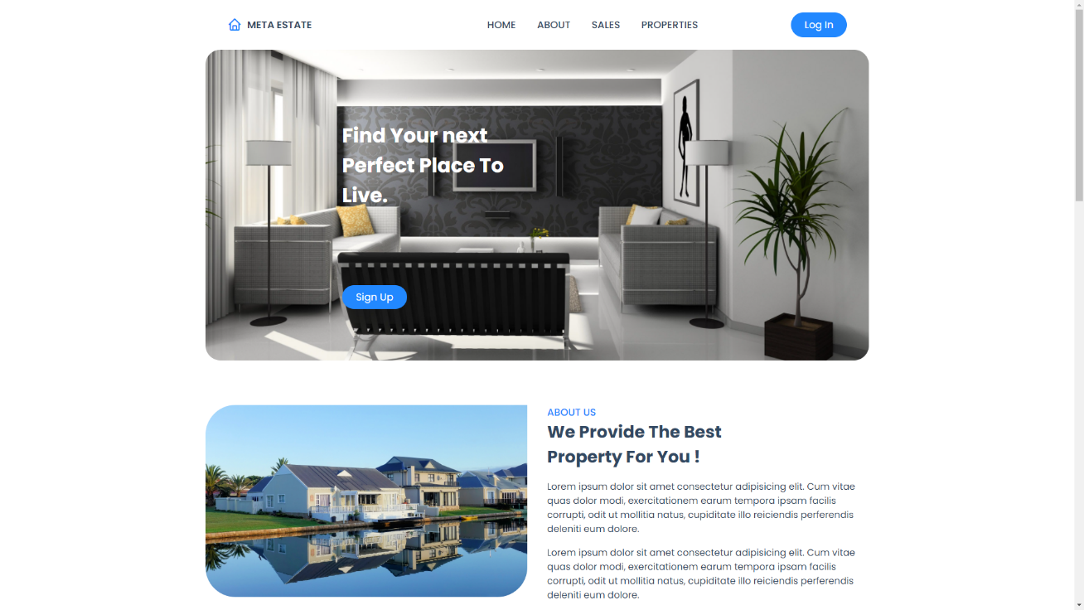

Figure 4.1.1: Home page

This is the home page of our website. After opening the website the visitor will see signup and log in button. As well as about, sales and properties section. By click in any particular section he can see the details of that section.

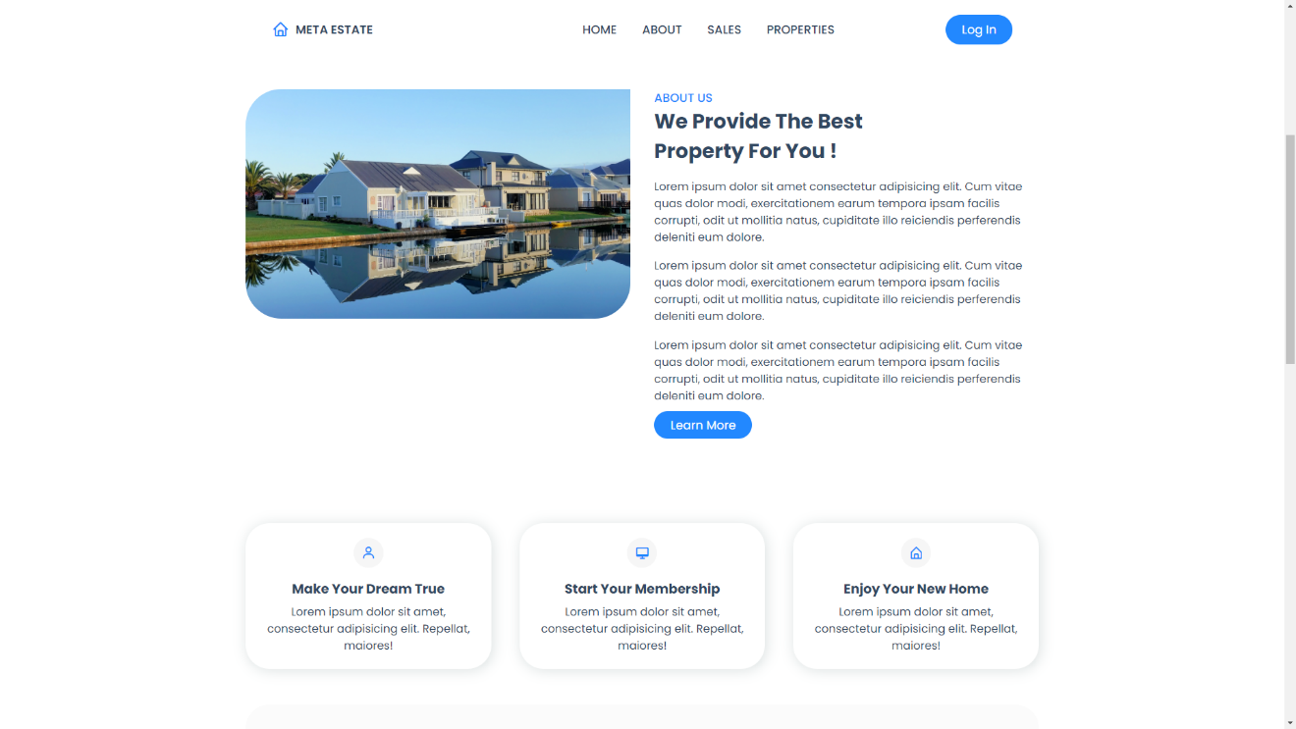

Figure 4.1.2: About us page

This is our about page. Here we have provided the details of our web app. This section contains every single detail about property, apartment, residence. Here we also provided details of our business strategy, types of our company and here we also have learned more button which contains more information.

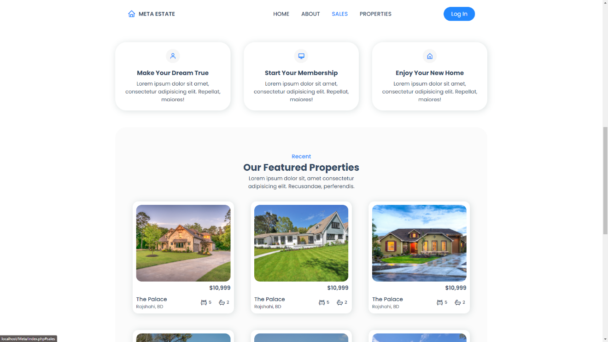

Figure 4.1.3: Sales page

This is our sales page. Here we have three buttons which are, Make your dream true. This button helps to find your dream property. Then Start your membership button is there which helps to start membership with us. The last button is Enjoy your new home. This section holds about the information of selected rooms. By clicking this button user can directly visit his new home virtually in 3D view.

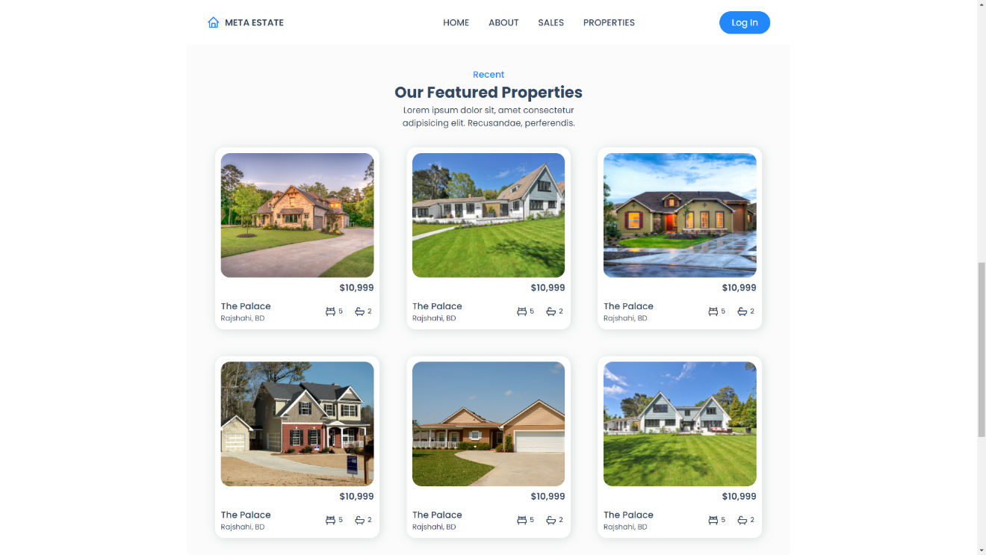

Figure 4.1.4: Properties page 1

The properties section contains all the properties that have added to our website. The section mainly contains the picture of every single property. This section also contains the name of those properties as well as the location where those properties situated. It also contains details about the number of bedroom and bathroom of those apartments or properties.

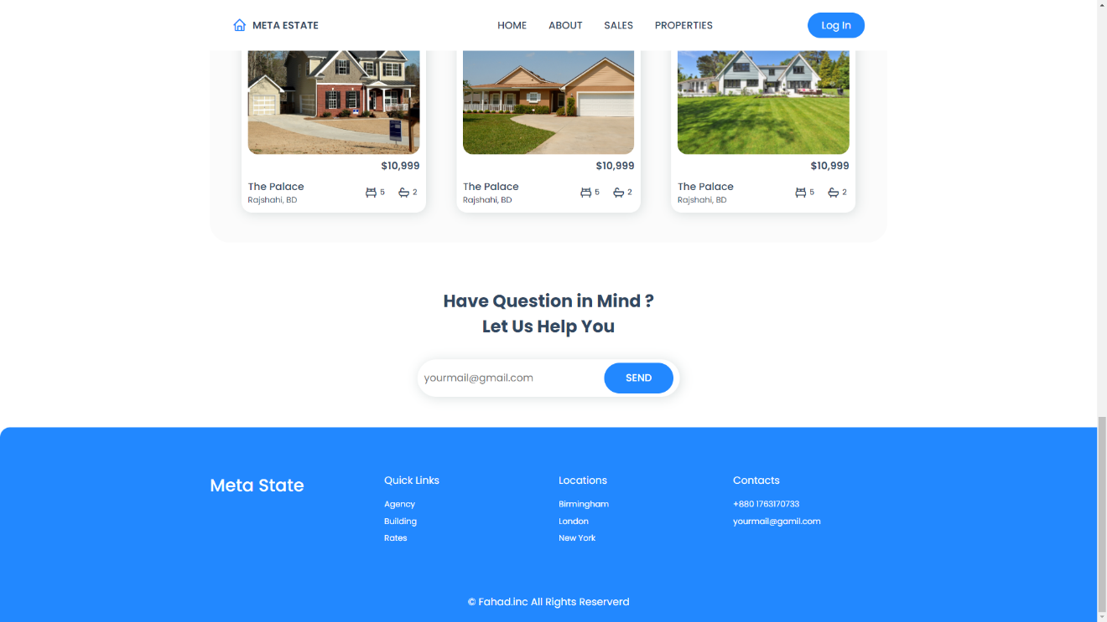

Figure 4.1.5: Properties page 2

This is help section where user can directly contact us via sending messages. At last, the footer section of this website holds quick links of agency, building and rates. Also, location where the properties situated. As well as contacts which holds the phone number and official email of our company.

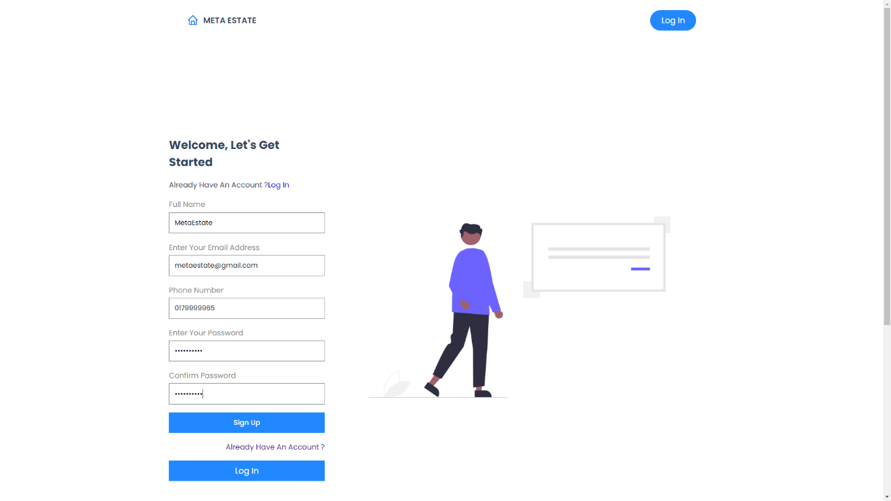

Figure 4.1.6: Sign-up page

Figure 4.1.5: Sign-up page

Figure 4.1.5: Sign-up page

Figure 4.1.5: Sign-up page

This is the sign-up page of our website. Here user can easily register name, email address, phone number and password. If user is already registered then he can log in from clicking log in button.

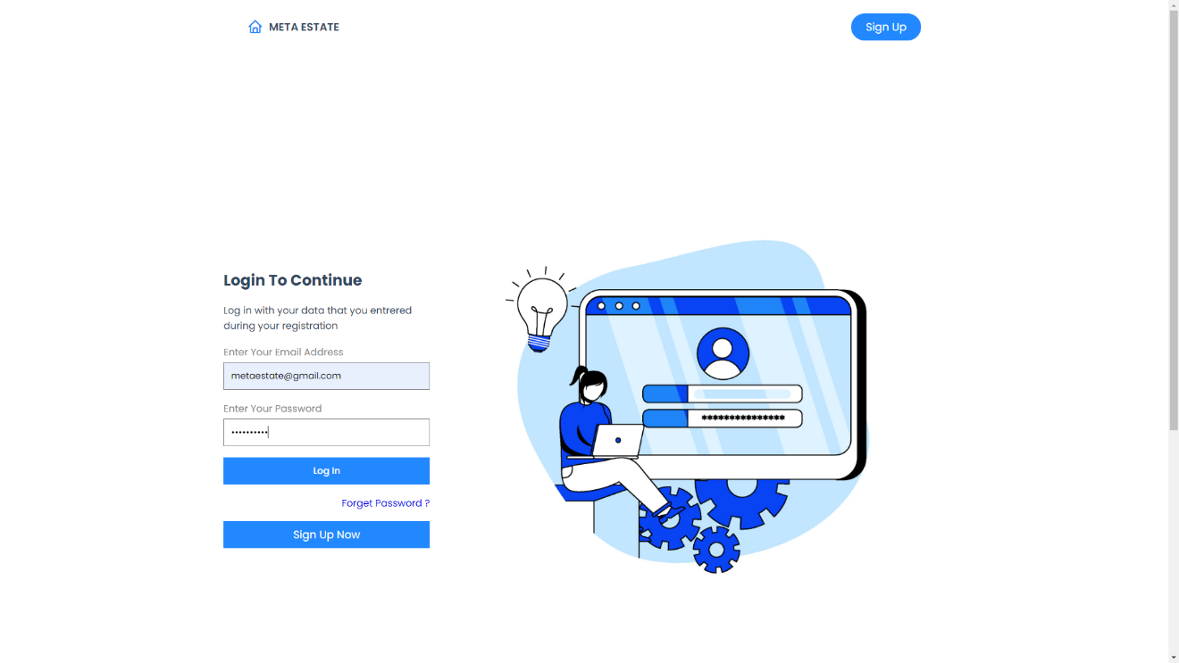

Figure 4.1.7: Log in page

A new user can’t log in to our page through our website because he or she has to sign up first. If he is registered then he can easily log in to our website. After log in he has full access of the website to visit the properties and select their favourite ones.

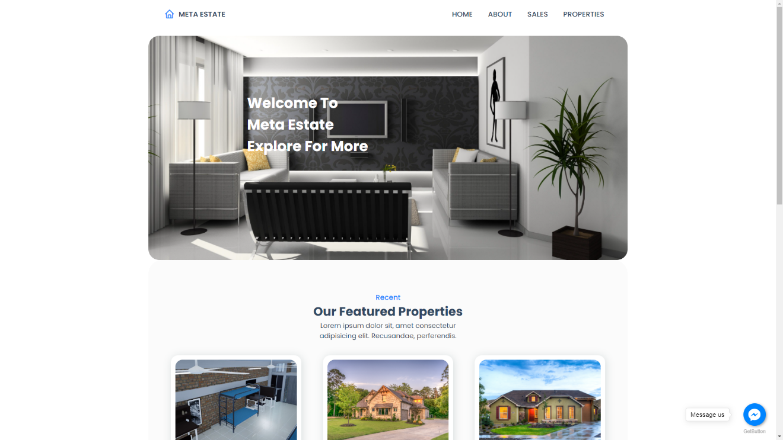

Figure 4.1.8: Welcome page

This is the welcome page of our website. After successful log in we welcome the user by this page. All the details of property, apartment, residence is here. By clicking the buttons user can visit the properties in a 3D view. Also, live chat option is here where user can easily send us messages about their quarry.

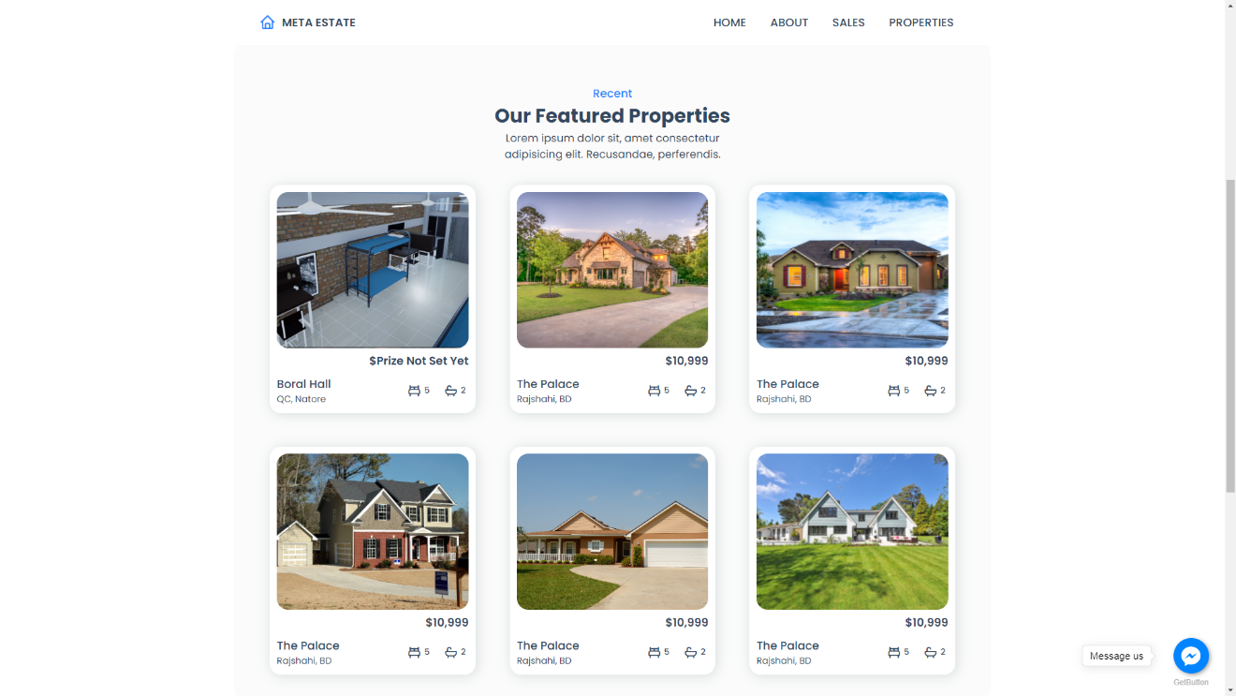

Figure 4.1.9: Properties page

Here are also some more properties of our web app. User can visit the properties in a 3D view. User can see the properties from the top view, bottom view, left view, right view, inside view & outside view.

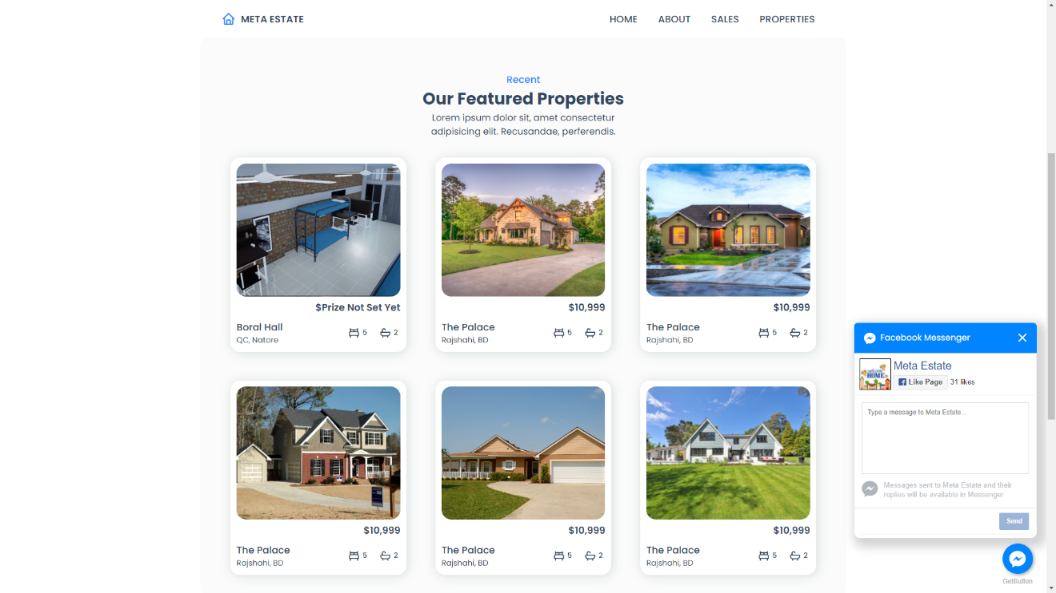

Figure 4.1.10: Messenger option page

Here is the Facebook messenger option where user can send messages easily. We have a Facebook page for the website. If any user want’s any help from us he can directly ask for help in this option. The message will come to our Facebook page’s inbox.

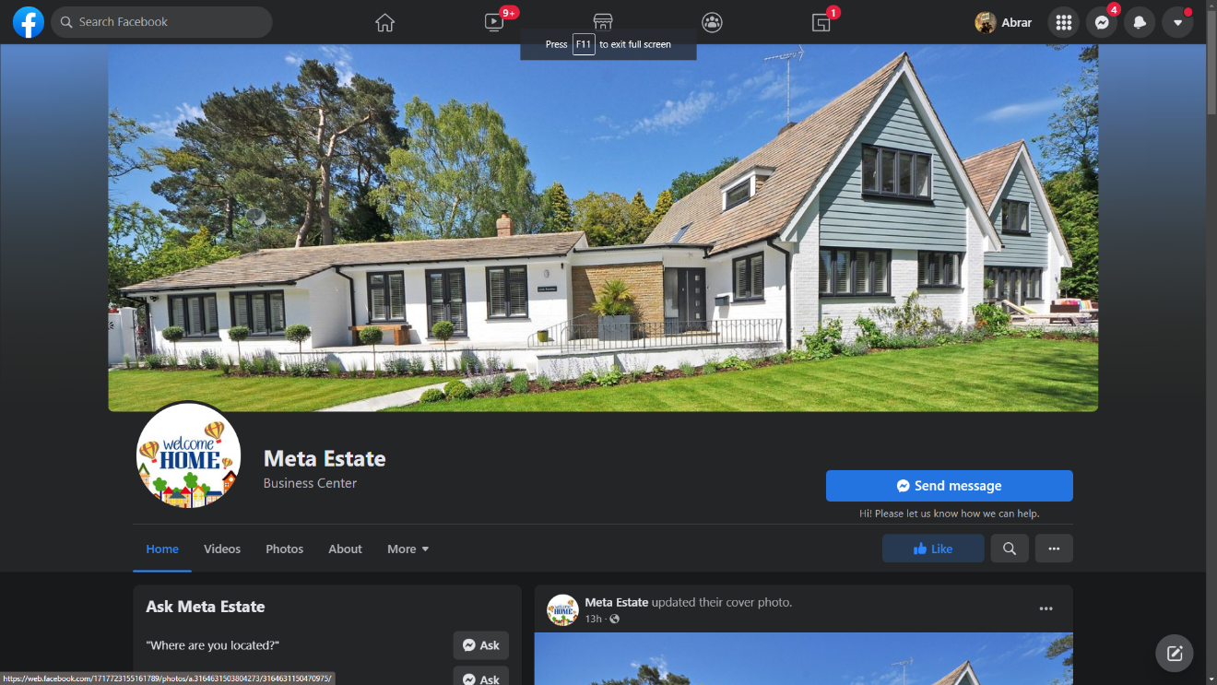

Figure 4.1.11: Our Facebook page

This is the Facebook page of our web app. Here all the details of our app are available. For any help from us user can easily ask for help and the message will come to this page. It will be help full for user to know more about his chosen property.

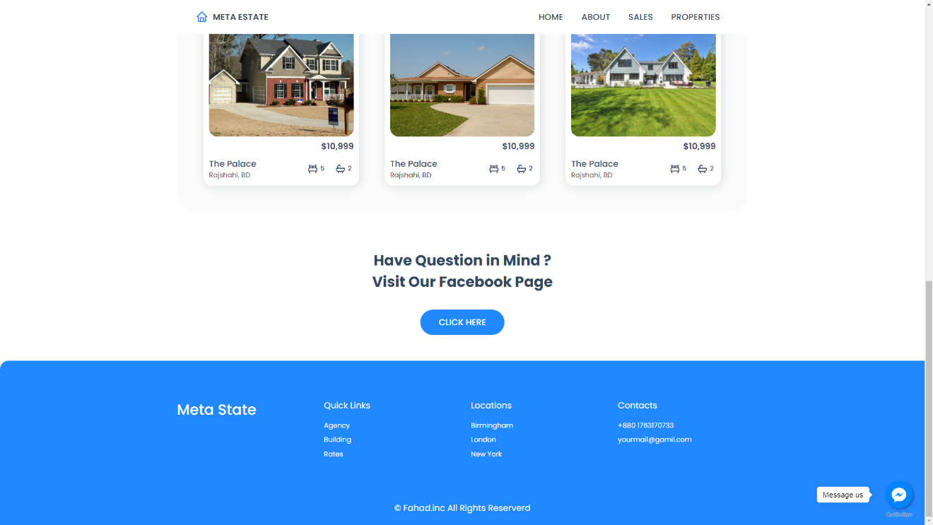

Figure 4.1.12: Facebook page’s link button

In this page the click here button is added which helps user to redirect to the Facebook page. User can visit our Facebook page easily using click here. In our Facebook page all the details about us will be available which will be helpful for the user.

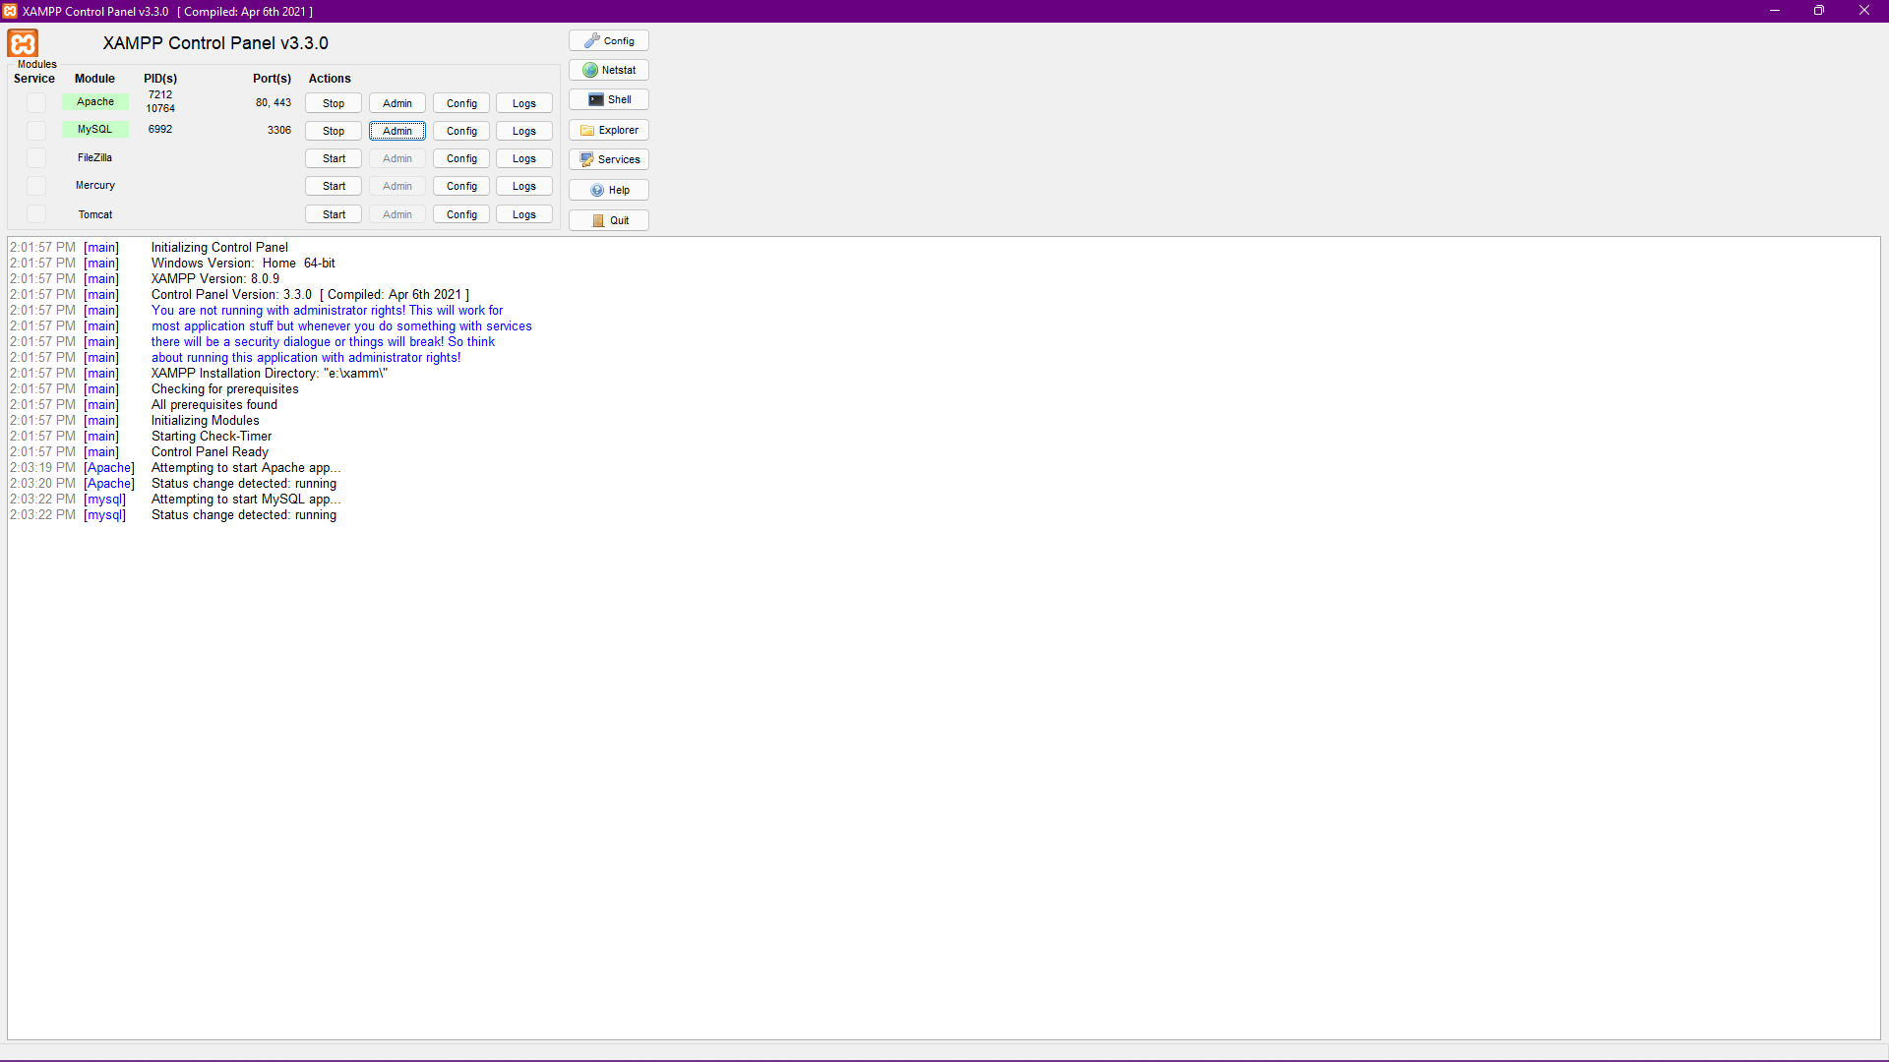

Figure 4.1.13: XAMP home page for database

This is the home page of XAMP. Our web application has a database, here all the information of user is stored. We have to start the database first to store the data. After starting it can store all data of the user. Admin can access here by clicking admin button.

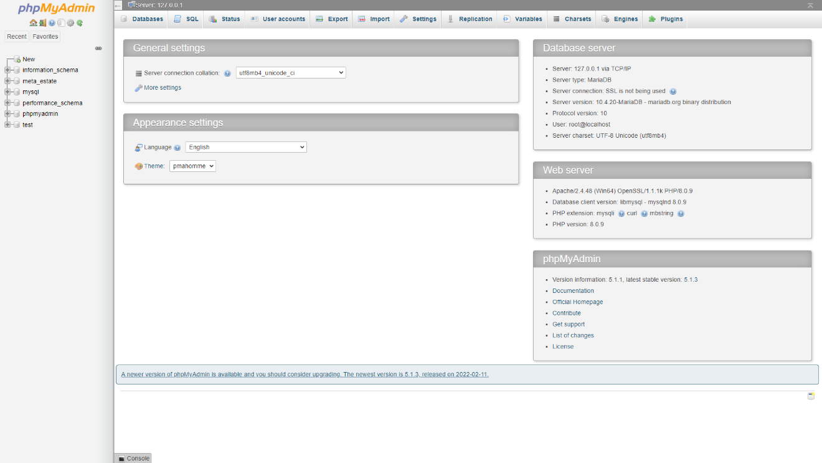

Figure 4.1.14: Database page

Here the database of our web app is stored. The name of the database of our app is meta_state. Here data table stores the data of the web app. phpMyAdmin is used here for database. Whenever any user sign up to our web app the data will store in this database.

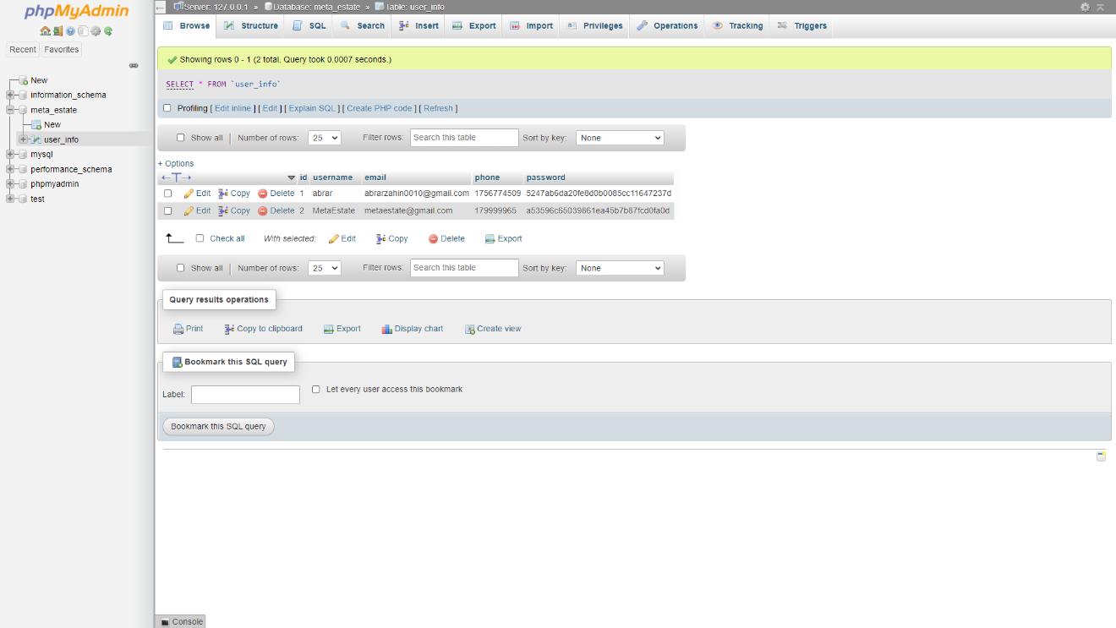

Figure 4.1.15: Data table of the database

In our database there is a table called user_info. All the information about the user is stored in this table. In the table there are 4 attributes: username, email, phone and password. In this data table all the information of the user is stored sequentially.

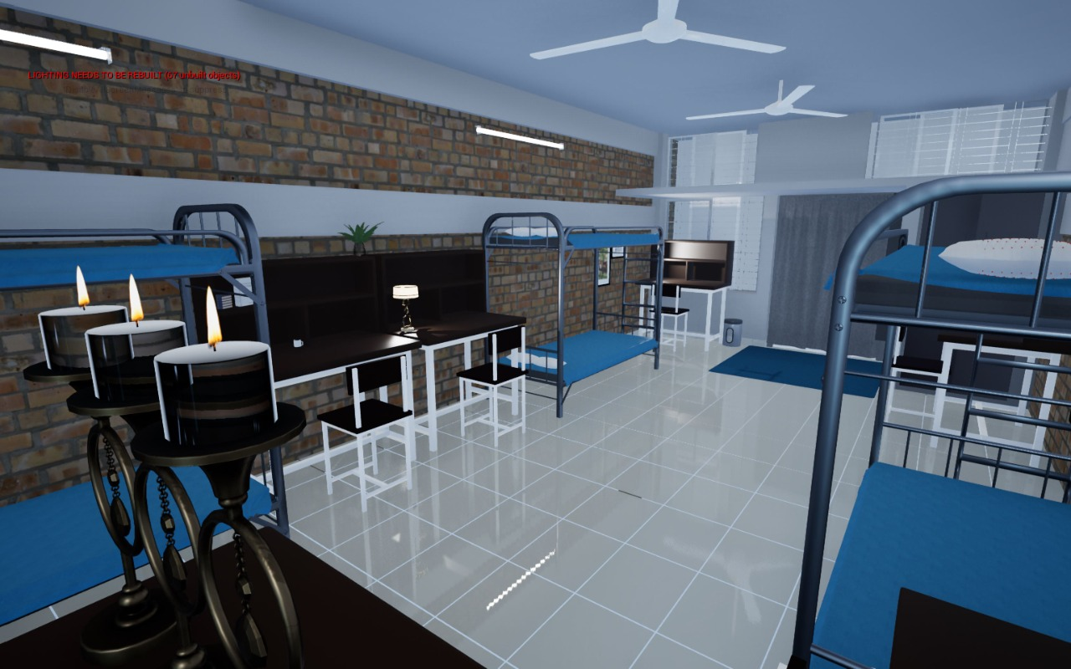

Figure 4.1.16: Boral hall’s room’s 3D view 1

This is the boral hall’s room’s 3D view. As the requirement we designed the room. User can visit the whole kitchen in a 3D view. By pressing ‘w’, ’a’, ’d’, ’s’ user can easily move the camera and ’q’, ’e’ to zoom in or out. User can experience a 3D view without going to the place physically.

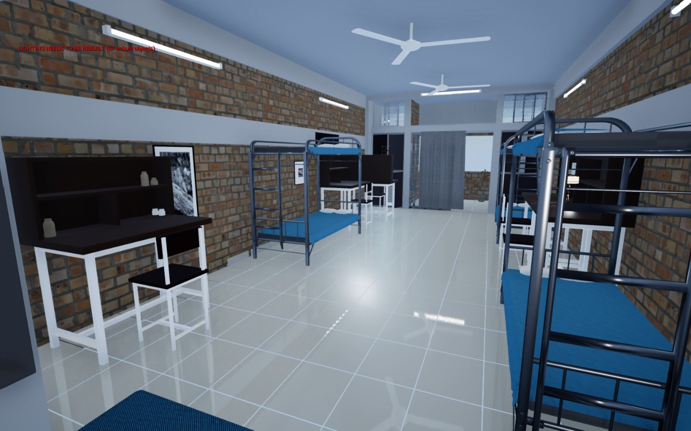

Figure 4.1.17: Boral hall’s room’s 3D view 2

This is the corner view of Boral hall’s rooms. User can visit the whole kitchen in a 3D view. By pressing ‘w’, ’a’, ’d’, ’s’ user can easily move the camera and ’q’, ’e’ to zoom in or out. User can experience a 3D view without going to the place physically.

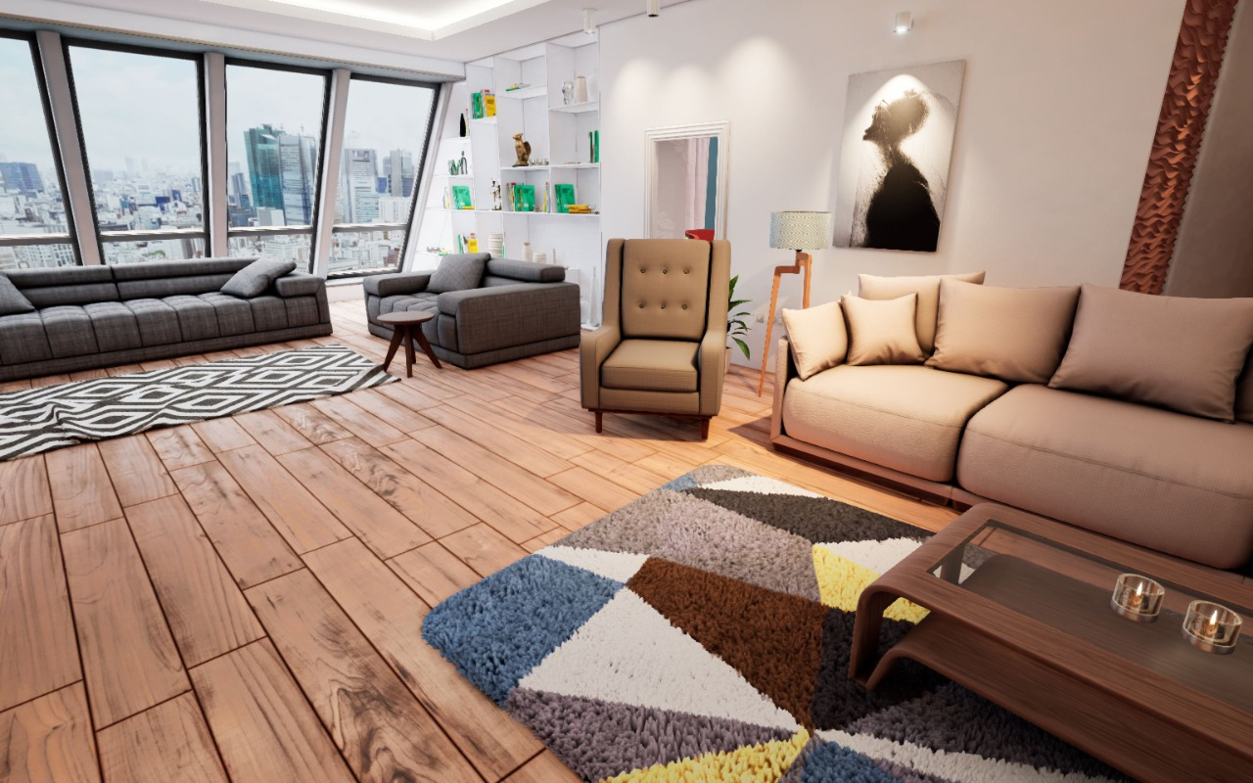

Figure 4.1.18: Living room of an apartment

This is the living room of an apartment. Here, we can decorate our room with sofa chair table or anything. We can change the colour of carpet and sofa from here and can see which one is more suitable for this place. There is also a painting which helps to decorate the room.

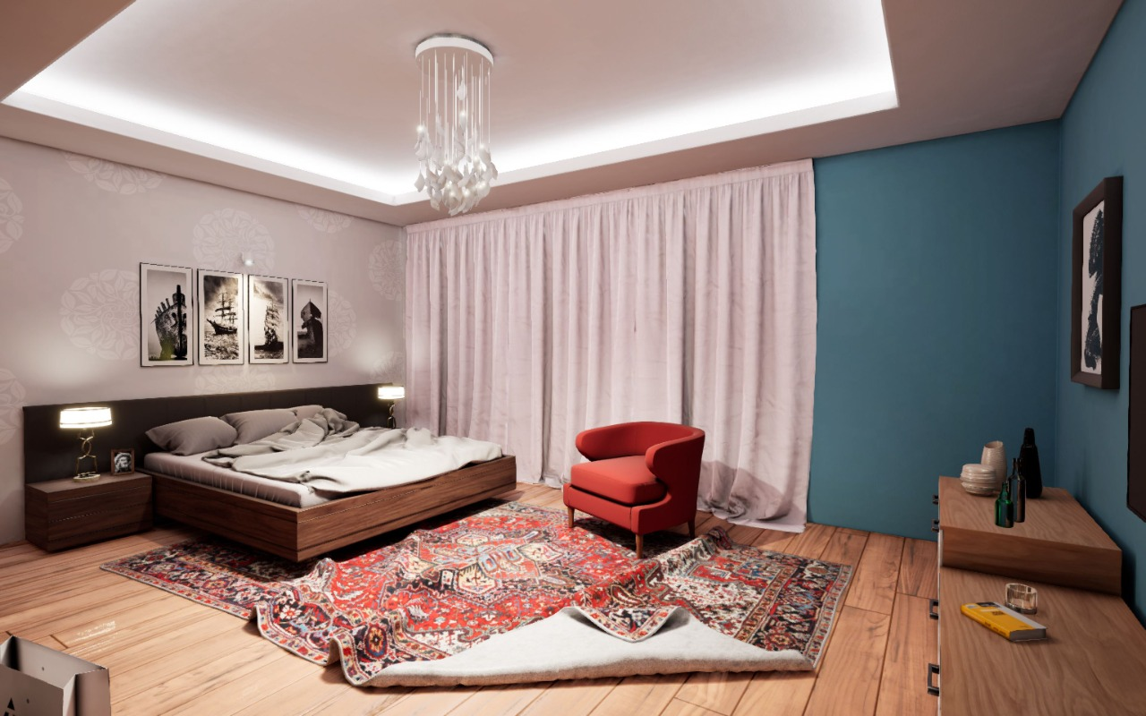

Figure 4.1.19: Bed room of an apartment

This is the bed room of an apartment. There are some paintings which helps to decorate the room. All the furniture can be replaced here as the user’s choice. Our designer team will help the user to change the design as their requirements.

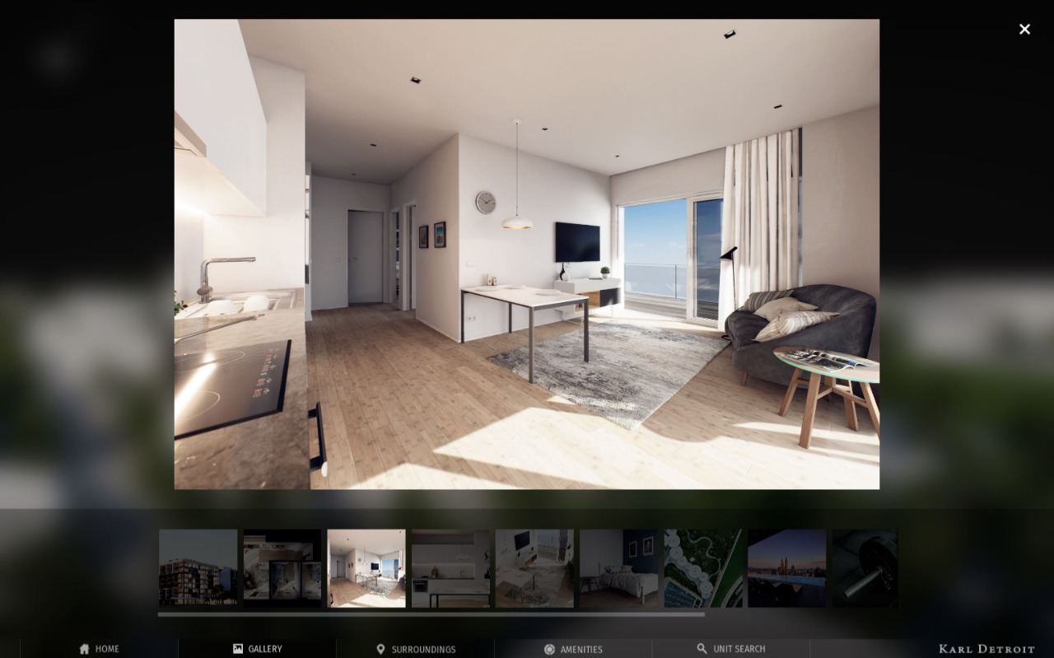

Figure 4.1.20: Drawing room of an apartment

This is the image of drawing room of an apartment. User can see the whole apartment’s images from our website. It will help them to choose the best apartment without going there physically which is a good time saving idea.

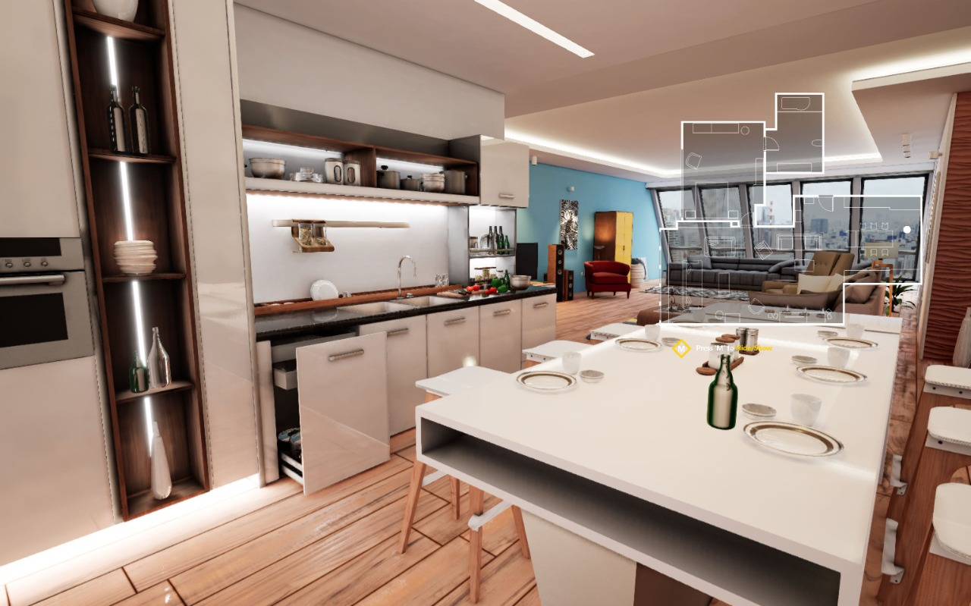

Figure 4.1.21: kitchen of an apartment

This is the kitchen of an apartment. User can visit the whole kitchen in a 3D view. By pressing ‘w’, ’a’, ’d’, ’s’ user can easily move the camera and ’q’, ’e’ to zoom in or out. User can experience a 3D view without going to the place physically.

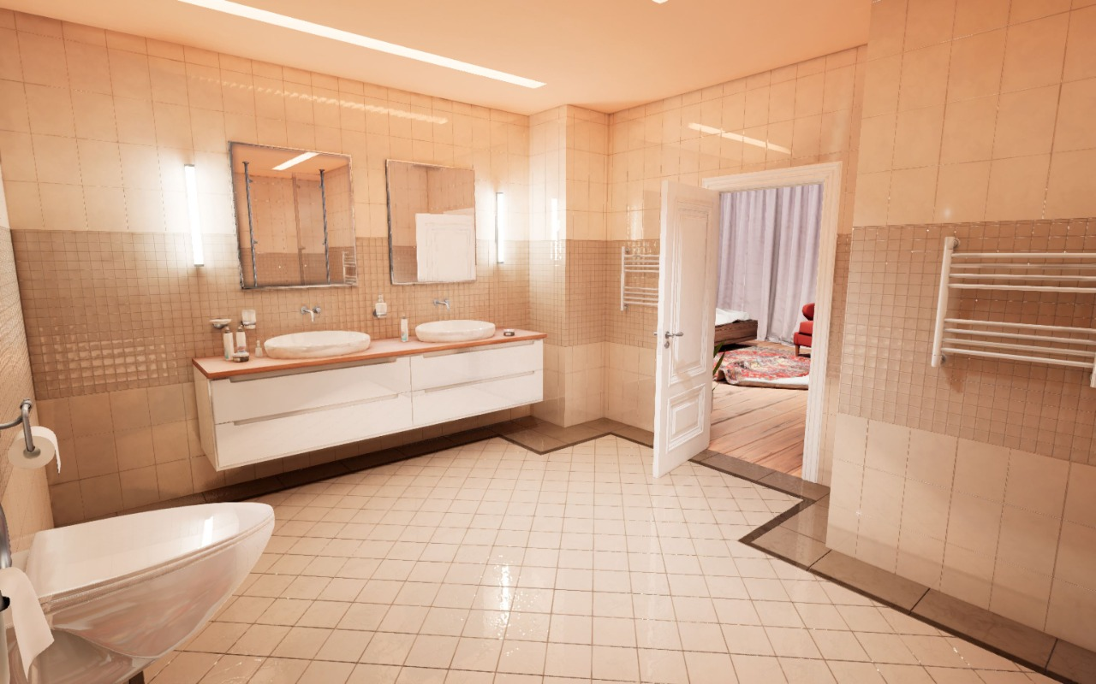

Figure 4.1.22: The washroom of an apartment

This is the washroom of an apartment. User can visit the washroom in a 3D view. By pressing ‘w’, ’a’, ’d’, ’s’ user can easily move the camera and ’q’, ’e’ to zoom in or out. User can see the whole washroom as he wanted which will help him to choose the apartment.

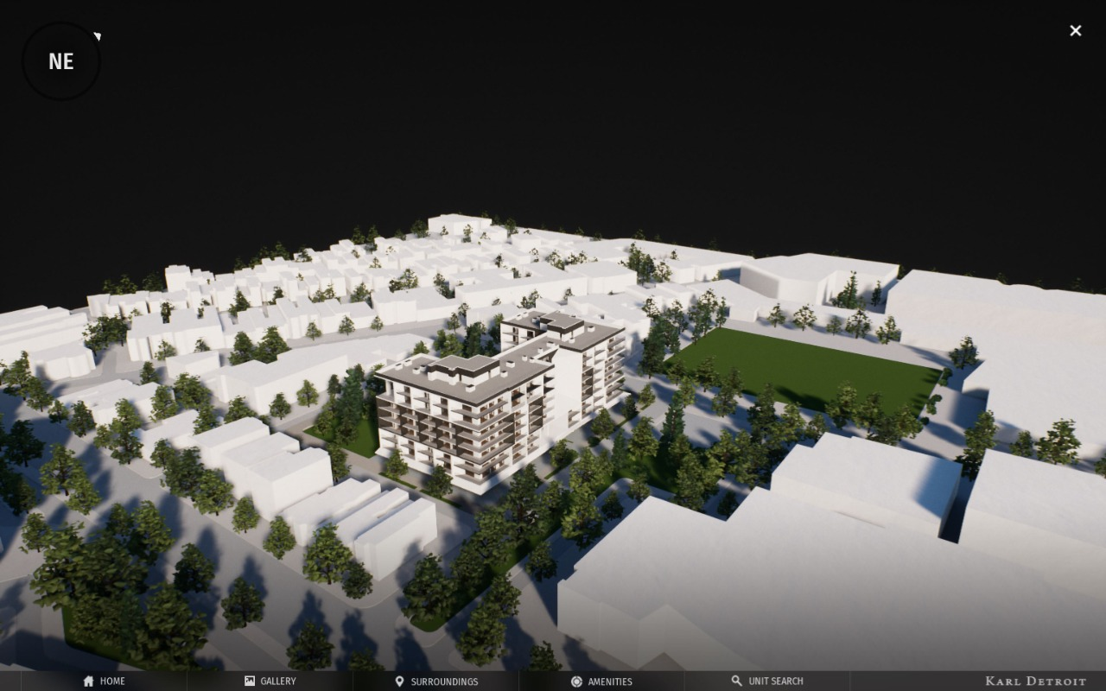

Figure 4.1.23: Outside of the apartment

This is the outside of the apartment where we can see the whole area around the apartment. We can also see by clicking the option home to see the home, gallery to see the images of the apartment from inside, surrounding to see all the area outside the apartment. In the unit search option user can find a flat as his choice.

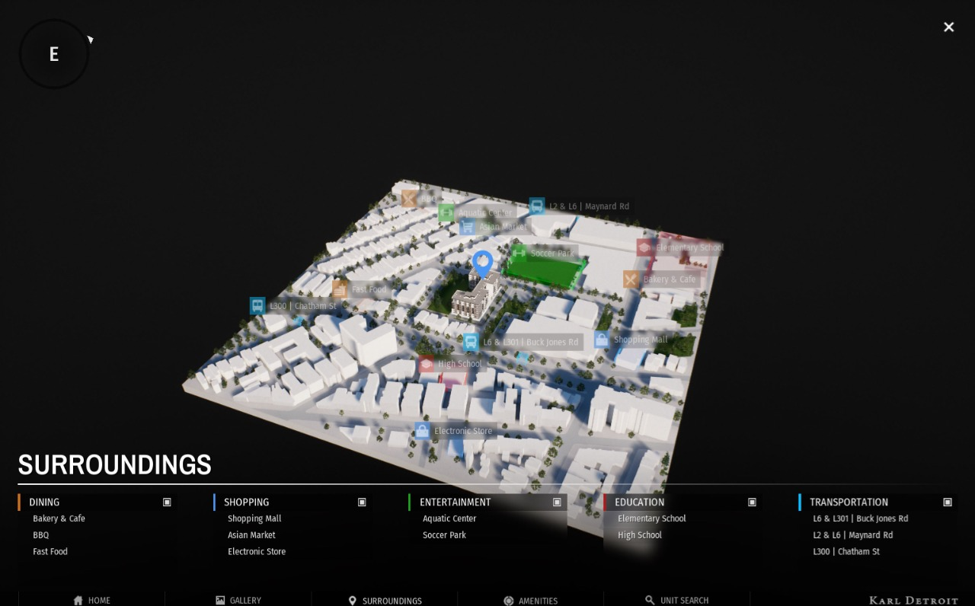

Figure 4.1.24: Map of the apartment area

This is a map of the area where apartment is available. User can see the map by using google maps which is basically 2D map but in our web app user can see the map in a 3D view which helps them to feel closer to the particular place. He also can see all the establishments near the apartment. The dining, shopping, entertainment, education and transportation options helps the user to find these places.

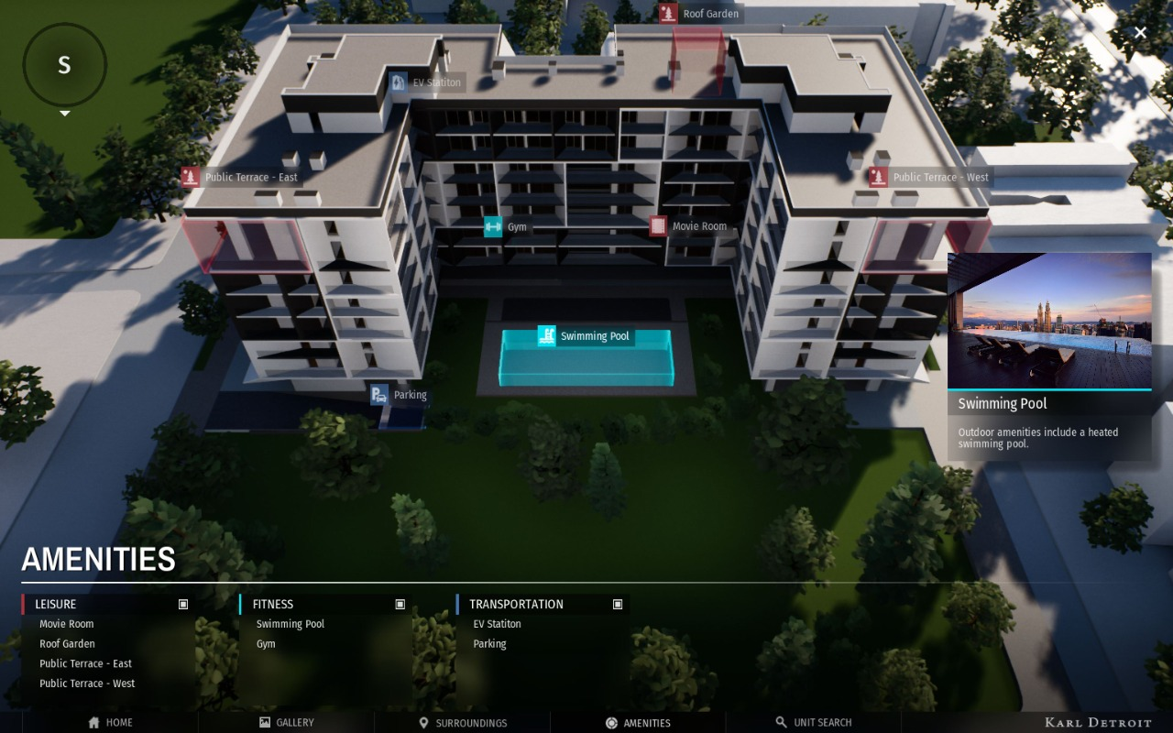

Figure 4.1.25: the top view of the apartment

This is the top view of the apartment where swimming pool is selected by the user. User can select all the components from the given list and can see its place. It helps the user to see what is situated around the apartment.

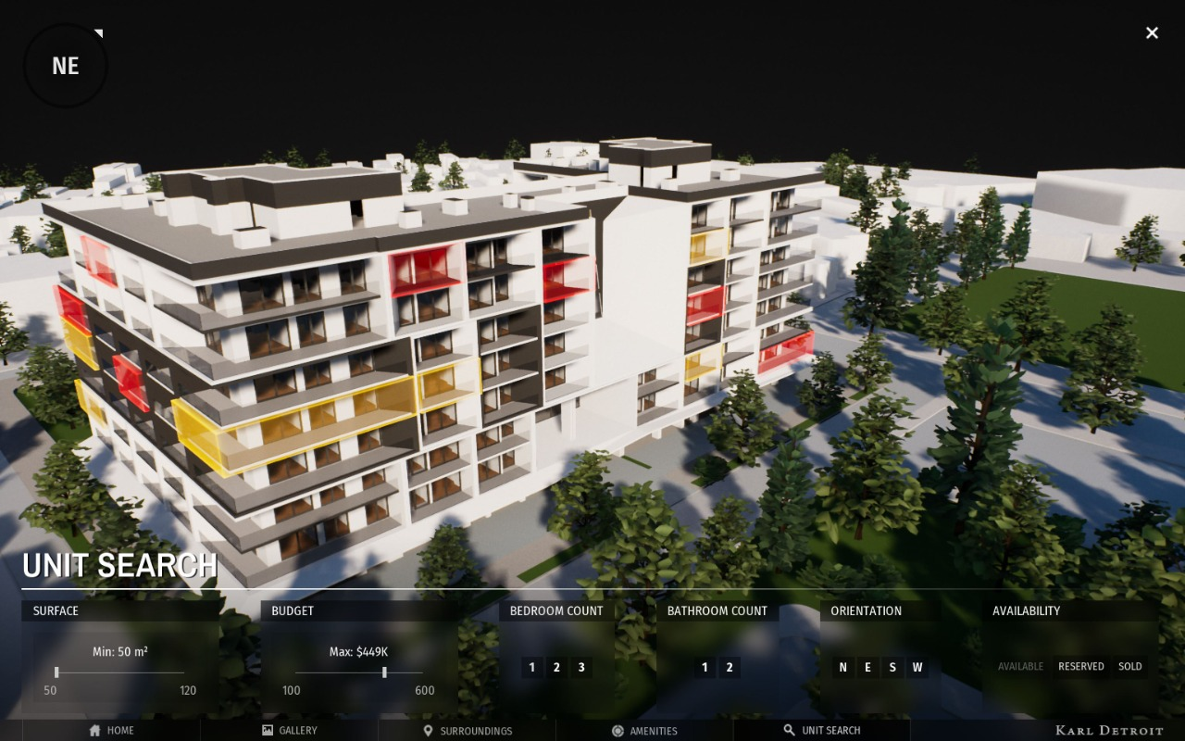

Figure 4.1.26: The outside view of an apartment

This is the outside view of an apartment where all the available flats are selected. Red mark flat is not for sale and yellow marked flat is for sale. In the unit search option user can find a flat as his choice.

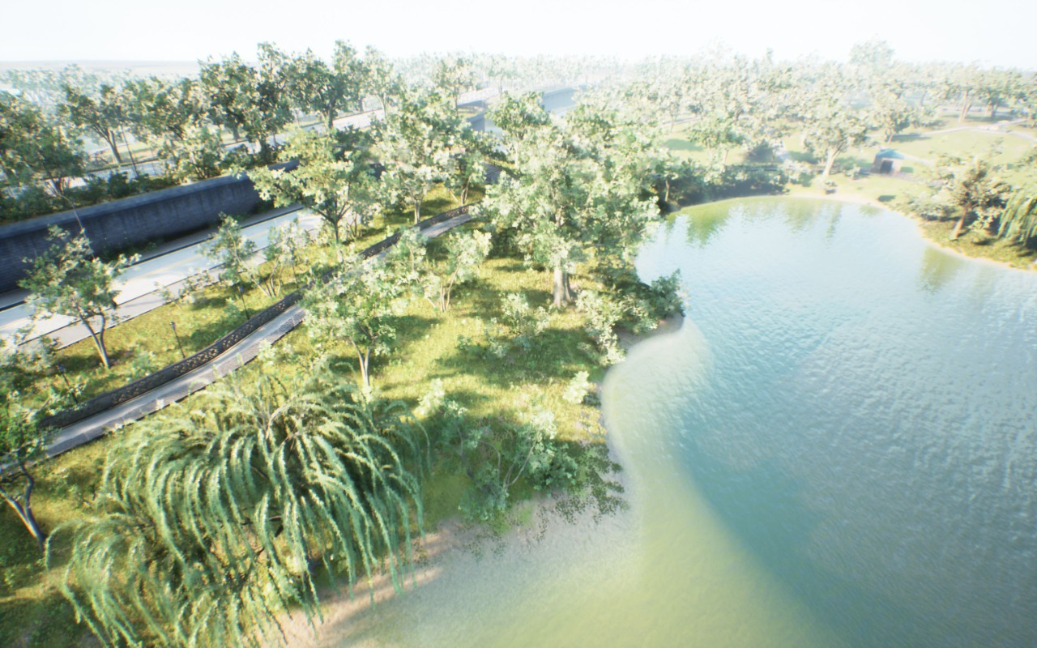

Figure 4.1.27: The Park

This is a property where a park is situated which is for selling. User can visit the whole park in a 3D view. By pressing ‘w’, ’a’, ’d’, ’s’ user can easily move the camera and ’q’, ’e’ to zoom in or out. The park is in a large area. Here many features are available such as 3D animation with sound effects.

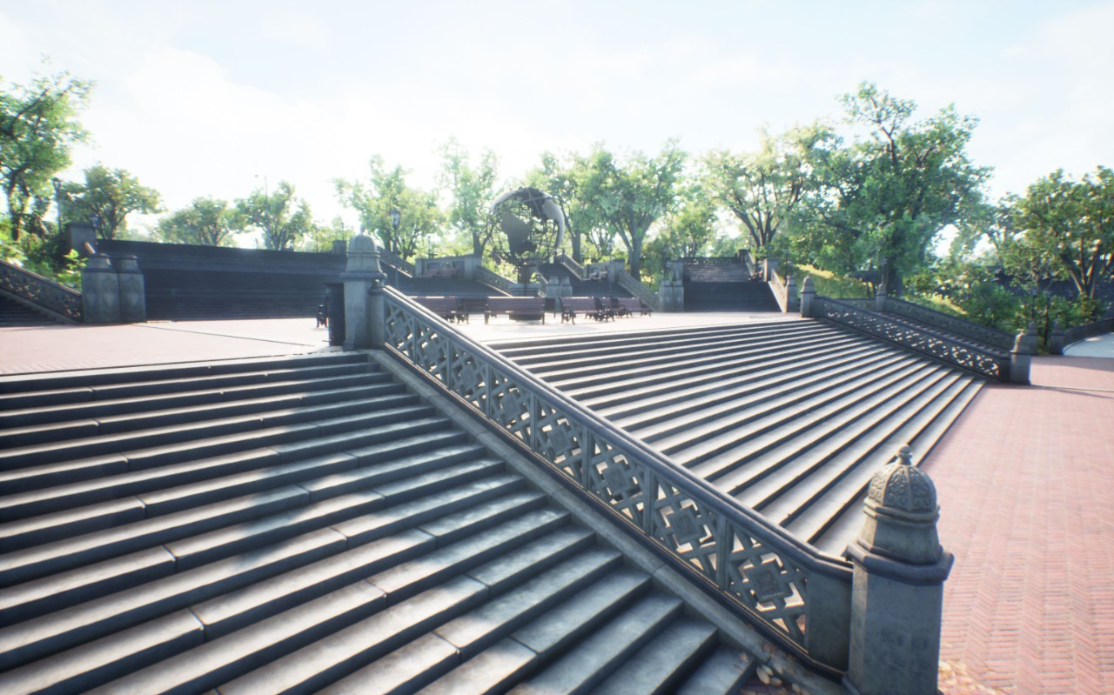

Figure 4.1.28: The gorgeous stairs of the park

The gorgeous stairs of the park for selling. All the designs and structures can be visited by the user in a 3D view here. By pressing ‘w’, ’a’, ’d’, ’s’ user can easily move the camera and ’q’, ’e’ to zoom in or out.

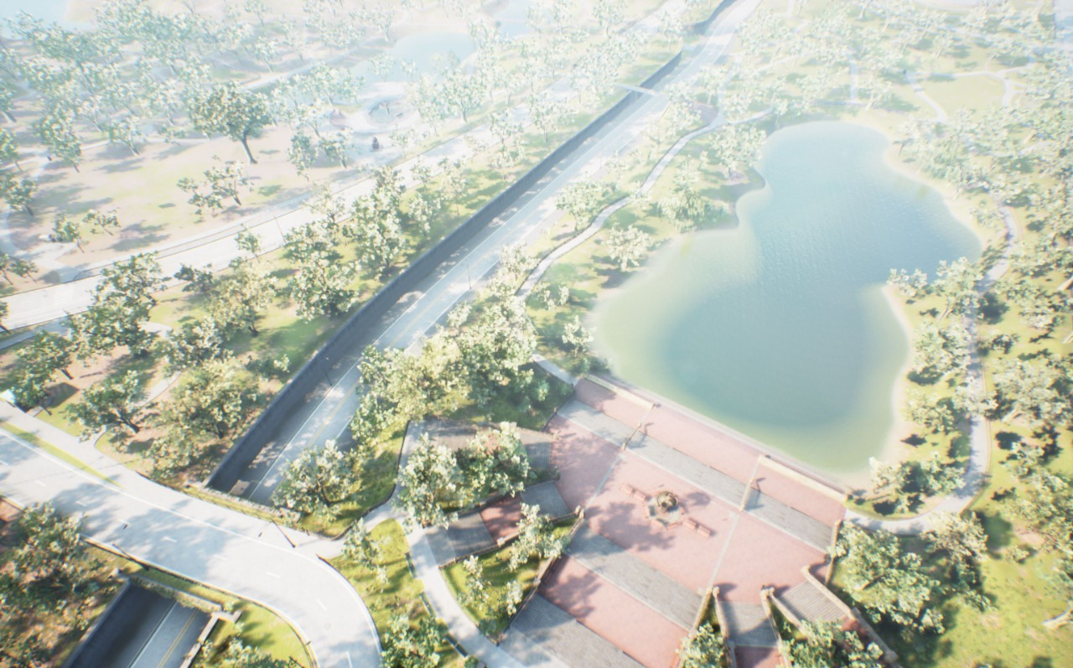

Figure 4.1.29: The top view of the park

This is the top view of the park. We can see the whole park from here. It’s situated in a large area. There are many trees and artificial structures are available to increase the beauty of nature. It can be visit by the user easily in a 3D view by using our web app.

**Chapter 5**

**CONCLUSION & COMPARISON**

**5.1 Introduction**

This chapter describes the future scope and extensions for the project. There is still a huge scope of implementing something new and more to the project which can make it to the level of a commercial product. This section also concludes stating the advantages and applications of this Real Estate Web Application.

**5.2 Conclusion**

This Real Estate Web Application “Meta-Estate” is a typical 3D web application using HTML, CSS, C#, PHP, JS and unreal engine. The buyer performs a browse for visiting the property.

Development of an online web based smart house renting system has been developed in this paper. The system can provide a framework that allows managers to conduct reasonable transactions within a limited time frame. This system is meant to satisfy the needs of rental house owners. Several user-friendly interfaces have also been adopted. The real time chat system will bring fluidity over the usage and connection between owner and tenants. Also, the location tracing system will be a major advantage for users as it will be easy to find the location of the house on a map. In addition, for the concern of security, this system has optimized secure and private data storage and verification system. This package will prove to be very powerful in satisfying all the requirements of the users [5]

Web 3D is a term used to describe interactive 3D content included in an HTML page, viewable by a common Web browser via a special 3D viewer. It uses the concept of Web 3D also indicate a possible evolution of the Web where the idea was abandoned page. We have an existing system called the next gallery This represents a photo gallery in a 3D web view. [5] But in our web app, we have a 3D house design where user can experience the whole house in 3D using any browser.

**5.3 Comparison**

Our proposed project is “Meta-Estate” - A 3D based home selling web application. It’s a new generation of web where we want to introduce it with the world. Though there are some architectural, environmental designing website exists from 2007 but we have implemented this technology for the first time in web platform. Where we are able to see 3D architectural view of a real environment in any type of web browser.

**REFERENCES**

1. J. Smith. “What is Web Application (Web Apps) and it’s Benefits.” techtarget.com. https://www.techtarget.com/searchsoftwarequality/definition/Web-application-Web-app (accessed May. 12, 2022).
2. M. Robert. “retailor.com | Homes for Sale, Apartments & Houses for Rent.” retailor.com. https://www.techtarget.com/searchsoftwarequality/definition/Web-application-Web-app (accessed May. 12, 2022).
3. “New Zealand at Expo 2020 Dubai – Virtual Pavilion Experience.” nzpavilionvirtualtour.co.nz. https://nzpavilionvirtualtour.co.nz/ (accessed May. 12, 2022).
4. B. Bawuah. “The Next Gallery.” thenext.gallery. https://www.thenext.gallery/ (accessed May. 12, 2022).